**DAILY ONLINE ACTIVITIES SUMMARY**

|  |  |  |  |  |  |  |  |  |
| --- | --- | --- | --- | --- | --- | --- | --- | --- |
| **Date:** | **20-05-2020** | | | | | **Name:** | **Rohan Mahaveer** | |
| **Sem & Sec** | **6th B** | | | | | **USN:** | **4AL17CS077** | |
| **Online Test Summary** | | | | | | | | |
| **Subject** | | **System software and compiler design (SSCD)** | | | | | | |
| **Max. Marks** | | **30** | | **Score** | | | **21** | |
| **Certification Course Summary** | | | | | | | | |
| **Course** | **Ethical Hacking** | | | | | | | |
| **Certificate Provider** | | | **Alison** | | **Duration** | | | **6hrs** |
| **Coding Challenges** | | | | | | | | |
| Problem Statement: 1. Write a Java Program which illustrates how to get column properties from ResultSet using ResultSetMetaData?  ResultSetMetaData is an object that can be used to get information about the types and properties of the columns in a ResultSet object. Below example shows how to get ResultSet column properties using ResultSetMetaData object.  2. Write a C Program to Reverse a Linked List in groups of given size. | | | | | | | | |
| **Status:** YES, Completed all Programs | | | | | | | | |
| **Uploaded the report in Github** | | | | | **YES** | | | |
| **If yes Repository name** | | | | | <https://github.com/rohanmahaveer/daily-status> | | | |
| **Uploaded the report in slack** | | | | | **YES** | | | |

Online Test Details: (Attach the snapshot and briefly write the report for the same)

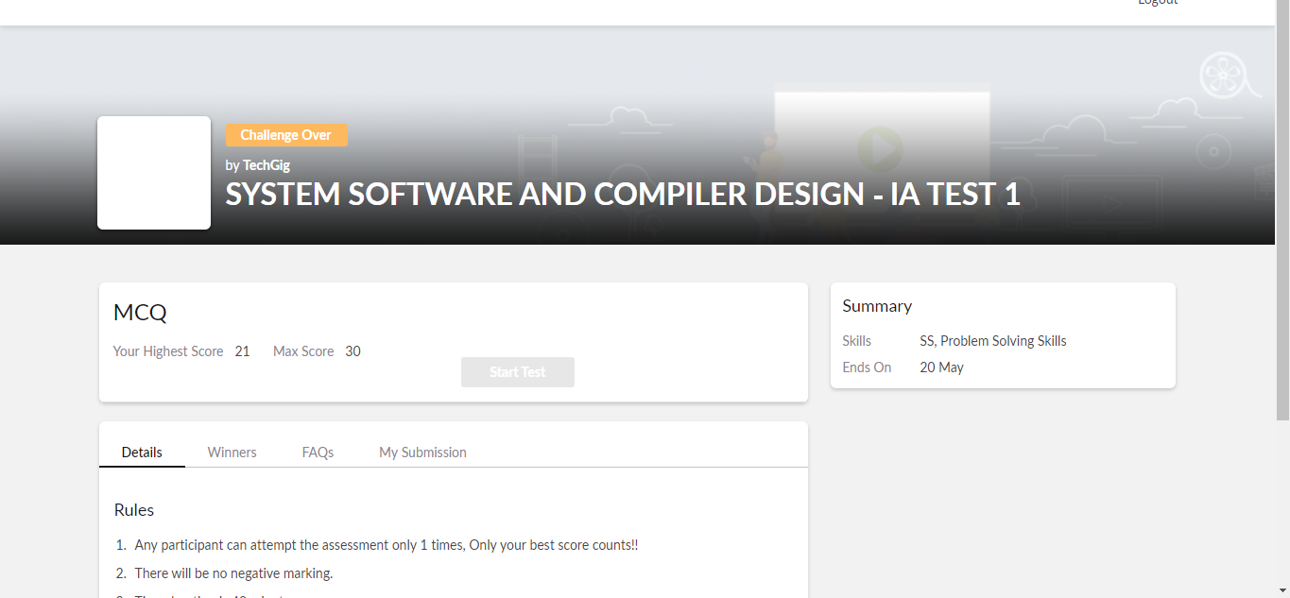

Scored 21 out of 30 in SSCD 1st I.A test

Certification Course Details: (Attach the snapshot and briefly write the report for the same)

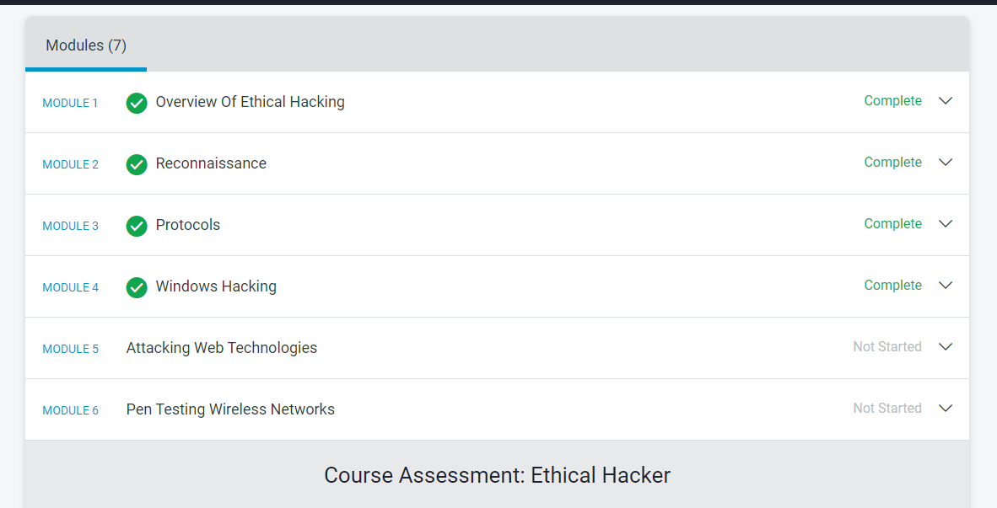

The above course is being taken up by me is based on Ethical hacking. It started with the CIA triad, today in online course I studied about the types of hacking in windows, and how to prevent different type of attack in windows hacking. The details of the course and certificate provider are mentioned in the above form.

Coding Challenges Details: (Attach the snapshot and briefly write the report for the same)

Program1:

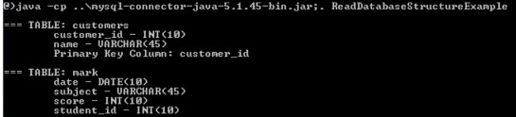

Program2:

